Project Name:

Purpose
To establish readiness of the project to move forward into the concept phase. Projects are reviewed for strategy phase readiness to begin the business case and concept planning; this includes assessment of the project for appropriate definition of need.

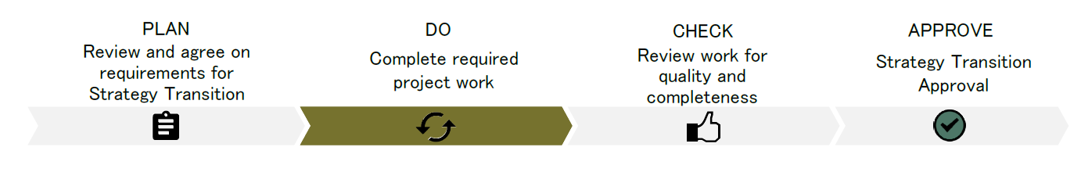
PLAN Timing: During start-up activities
Planning for Strategy Phase
The community group representative and city liaison meet to identify the required deliverables and handover documents. See the Community Group Led Construction Projects Guide and Strategy Document for details. If the project requires other deliverables, items can be added to the other requirements area. The community group representative, city liaison and supervisor sign, indicating that they agree to the deliverables in the “PLAN” section.

The city liaison and supervisor identify the review team composition, that includes an city project manager and may include other city representatives, external representatives and experts as appropriate to the size, complexity, and sensitivity of the project.

Agreement on Readiness Criteria
Community Representative |  |  |  | Date (yyyy-mm-dd)
City Liaison |  | City Liaison Supervisor |  | Date (yyyy-mm-dd)

DO Timing: During work execution activities
Strategy Readiness Criteria
The community group leads the completion of all agreed upon deliverables with support from the city liaison. The community group confirms that all “Mandatory for Readiness” items have been completed and discusses with the city liaison that the project is ready to move to the next step in the process - CHECK .

Deliverable | Mandatory for Readiness  PLAN | Completed/  Verified  CHECK | Handover Documents | Comments
Strategy Document
Organizational Profile | ✓ | ☐ | ☐
Project Description | ✓ | ☐ | ☐
Demographics | ✓ | ☐ | ☐
Context Analysis | ✓ | ☐ | ☐
Activity Based Needs Assessment | ✓ | ☐ | ☐
Alternatives | ✓ | ☐ | ☐
Committee Structure
Committee Terms of Reference | ✓ | ☐ | ☐
Public/Stakeholders
Public Engagement Charter/Plan | ✓ | ☐ | ☐
Public Engagement Results  “What we Heard” | ✓ | ☐ | ☐
Other Requirements
 | ☐ | ☐ | ☐
See Community Group Led Construction Project Guide for Glossary (definitions) and Templates

CHECK Timing: Once work as defined in DO “Mandatory for Readiness” is substantially by the Community Group
The city liaison convenes the review team that includes the community representative(s) and city project manager and others appropriate to the size, complexity and sensitivity of the project. The mandatory deliverables are reviewed by the review team for completeness and quality. Depending on the scope of the project this check phase may require a circulation of the documents.

The community representative, city liaison and their supervisor, city project manager and their supervisor sign indicating all items have been completed and verified. This confirms the project is ready to move to the last step of the process - APPROVE.

Review Team:

Deliverables Completed and Verified

Community Representative  (Position) |  | Community Representative  (Position) |  | Date (yyyy-mm-dd)
City Liaison |  | City Liaison Supervisor |  | Date (yyyy-mm-dd)
City Project Manager |  | Project Manager Supervisor |  | Date (yyyy-mm-dd)
APPROVE Timing: Once work of phase is complete
The package is review by the City Liaison Director and approved to move forward into concept phase.
Authorization for project initiation.
Name  City Liaison Director |  | Signature |  | Date (yyyy-mm-dd)

