
Community Facility Partner Capital Grant

2016
Application

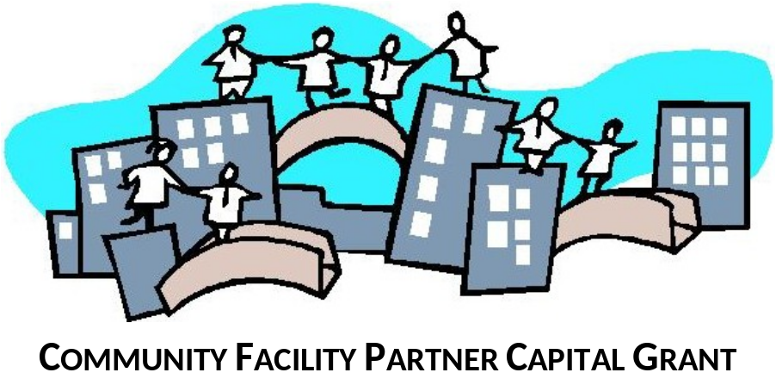

Deadline
4:30 p.m. Friday, April 1, 2016
Grant submissions:
- Applications forms to be submitted by email to grants@edmonton.ca or delivered to Community Services Reception
11th fl. CN Tower 10004 – 104 Ave. NW
- You will receive an email acknowledging receipt of your application
- For information:
email grants@edmonton.ca or call 780-496-4933
FREEDOM OF INFORMATION AND PROTECTION OF PRIVACY (FOIP) STATEMENT
Personal information on this form is being collected under the authority of section 33(c) of the Freedom of Information and Protection of Privacy Act by the City of Edmonton, Community Services, and will be used for the administration and management of the Community Facility Partner Capital Grant program. The aggregate data will be used by Community Services for planning and evaluation and may be shared with other agencies as deemed appropriate by the City of Edmonton. If you have any questions about the collection, use or disclosure of your personal information, please contact the City of Edmonton, Community Services Grants Office at 780-496-4933.

Part A – APPLICANT INFORMATION
ORGANIZATION INFORMATION
Legal Name of Organization:
Organization type: Not For Profit Public Service Provider Private Sector
Is organization a GST registrant?
No Yes If yes. What portion of GST is recoverable? 100% 50%
Mailing Address: |  | Postal Code:
Organizational Email: |  | Web site:
Contact Person #1 Name: |  |  | Daytime Phone:
Position: | Email:
Contact Person #2 Name: |  |  | Daytime Phone:
Position: | Email:
Mandate/purpose of your organization

What are the primary activities that will take place in facility? (indicate all that apply)
Arts & Heritage
Multicultural
Recreation/Amateur Sport
Social Services/Community Development
Other
Part B – PROJECT INFORMATION
Project Type (check ONLY ONE): Project Planning  Preserve / Rehabilitation  Enhance (includes additions)  Build New |  |  |  | Proposed completion date of CFPCG Project:  Start date for work on project:  Indicate year project construction is to start:  2016 2017 2018 2019 other:
CFPCG Project Descriptive Name:
Project Partners (if any):
PROJECT FACILITY INFORMATION
Name/description of Existing or Proposed Facility:
Street Address:
Project located on City of Edmonton land? | No Yes – If Yes, name of park/other City property:
Do you have a lease/license for your facility? No Yes – If Yes, name of landlord:
Does organization’s facility involve using space within a facility owned or operated by another organization?
No Yes
If Yes, please briefly describe situation:
Is the facility open for public use (usage fees may be charged)?
Yes No –briefly describe situation:
Percentage of facility users who are Edmontonians: %
Project Summary: Briefly describe (maximum 250 words) a) the proposed scope of the capital project, and b) feasibility and potential impact of phasing overall project.
Phasing or multi-year funding may be required while looking for additional funding. Any phases (except for planning) should result in a usable facility if additional funding comes in slowly or is not forthcoming. This may also enable the City funding to be provided in installments based on clear deliverables.
For planning projects, be specific about what assessment work has been already done to determine the project that needs to be planned and what are the items that will be intended result of the planning work. Note: a planning grant is intended to enable a project on City land to obtain concept phase approval or to bring a project to the detailed design and construction stage and will generally only be received once for any final construction project.
Fill in figures from Part C – Project Budget (for planning type project – only include costs for planning, not entire project)
Total CFPCG Project Cost: $ |  | Total Eligible Costs  (costs excluding invoices dated prior to Apr 1 last year and refundable GST):  $ |  |  | Total Grant Request: $  (max is 25% Eligible Project Costs but request may be less than max allowed)
If the CFPCG funding is approved, does your organization currently have sufficient funds to complete the project?
Yes No
If No – briefly explain plans to secure funding:
Are you presently working with one or more City of Edmonton staff persons?  No Yes  Are you presently working with one or more Edmonton Arts Council staff persons?  No Yes |  |  | Contact:  Phone Number:  Email:  Role with your project:
Contact:
Phone Number:
Email:
Role with your project:

PART C – PROJECT BUDGET - attachment
PART D - BUSINESS CASE - attachment
DECLARATION
We, the undersigned Officers of the organization, hereby represent to the City of Edmonton and declare that to the best of our knowledge and belief,

We are duly authorized to represent and have legal and/or financial signing authority for the organization
The information provided in this application package is truthful and accurate and endorsed by the organization
The application is made on behalf of the organization with the Board’s full knowledge & consent

Dated at | Edmonton | ALBERTA, this |  |  |  | Day of |  |  |  | 2014
 |  |  |  |  | (Day) |  |  |  | (Month)
Signature of First Signing Officer/Director |  |  |  | Print Name |  |  |  | Title
Signature of Second Signing Officer/Director (required) |  |  |  | Print Name |  |  |  | Title

CHECKLIST
Documents – Submit in electronic format Documents needing signatures to be scanned after signing.
Applicant Check off | Item # |  | Required Items for all applications | Grants Office
 | 01 |  | Complete Application parts A,B,C & D –– Signatures required on Application Declaration and Business Case
Supporting Documentation
 | 02 |  | EFT – Electronic Funds Transfer (EFT) Payment Vendor Registration (submit to request EFT payments or to update information such as bank account #, email, mailing address)
 | 03 |  | Quote(s) for costs listed Part C – Project Budget Spreadsheet
 | 04 |  | (First time applicants) Constitutional Documents (documents from an applicant’s incorporation)  (All applicants) Amendments to any Constitutional documents
 | 05 |  | Most recent ‘proof of filing’ of annual return
 | 06 |  | Board Minutes supporting the project
 | 07 |  | Documentation confirming necessary approvals are in place to proceed with the project  Project on City Land  concept phase approval letter from City (required except for Planning type projects):  Project NOT on City land  letter from landlord giving permission to undertake project or excerpt from lease/license confirming permission to undertake project.
 | 08 |  | Last year’s Audited or Independently Reviewed Annual Financial Statements. These should include the prior year’s financial data for comparison.  (Note –2 signatures required)  Set of Annual Financial Statements minimally must include  Statement of Financial Position (sometimes called Balance Sheet), and  Statement of Operations (sometimes called Statement of Revenue and Expenses)
 | 09 |  | If financial statements are internally audited/reviewed please provide  most recent year end bank reconciliation  Investment account statements for the fiscal year end date for each account included in
 | 10 |  | Current Year to Date Financial Statements and investment account statement(s) to February of this year. Investment account statements to February or most recent available.  Minimally must include  Statement of Financial Position (sometimes called Balance Sheet)  Statement of Operations (sometimes called Statement of Revenue and Expenses)
 |  |  | Other Documentation - Business Case Appendices
 |  | 11
 |  | 12
 |  | 13
 |  | 14
 |  | 15
 |  | 16
NOTE: The City of Edmonton may request additional information from applicants or comments regarding the project from staff from the City of Edmonton, Edmonton Arts Council, Edmonton Heritage Council or Edmonton Sport Council

