Project Name:
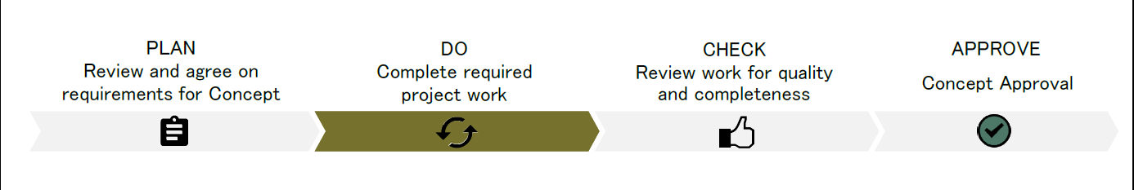
Purpose
To establish readiness of the project to move from the concept to the design phase. Projects are reviewed for readiness to begin design work and complete a municipal improvement agreement that will define the provision of municipal support/oversight through the life of the project or for the provision of the improvement.

PLAN
Planning for Concept Phase Transition
The community group representative, city project manager and city liaison meet to identify the required deliverables and handover documents. See the Community Group Led Construction Projects Guide for details. If the project requires other deliverables, items can be added to the other requirements area. The community group representative and city project manager sign, indicating that they agree to the deliverables in the “PLAN” section.

The city project manager, city liaison and community group identify the review team composition, that may include other city representatives, external representatives and experts as appropriate to the size, complexity, and sensitivity of the project.

Agreement on Readiness Criteria
Community Representative  (Position) |  | Community Representative  (Position) |  | Date (yyyy-mm-dd)
City Project Manager |  | City Project Manager Supervisor |  | Date (yyyy-mm-dd)

DO Timing: During work execution activities
Concept Readiness Criteria
The community group leads the completion of all agreed upon deliverables with support from the city project manager and city liaison. The city project manager leads the development of the municipal improvement agreement in collaboration with the community group.

The community group confirms that all “Mandatory for Readiness” items have been completed and discusses with the city project manager that the project is ready to move to the next step in the process - CHECK.

Deliverable | Mandatory for Readiness | Completed/ Verified | Handover Document | Comments
Scope
Business Case | ✓ | ☐ | ☐
Functional Program & Concept Pre-Design Drawing | ✓ | ☐ | ☐
Cost
Project Estimate | ✓ | ☐ | ☐
Operating Estimate | ✓ | ☐ | ☐
Public Engagement Plan Update | ✓ | ☐ | ☐
Municipal Improvement Agreement | ✓ | ☐ | ☐
Other Requirements
 | ☐ | ☐ | ☐
 | ☐ | ☐ | ☐
 | ☐ | ☐ | ☐

See Community Group Led Construction Project Guide for Glossary (definitions) and Templates

CHECK Timing: Once work as defined in DO “Mandatory for Readiness” is substantially complete by the Community Group
The city project manager convenes the review team that includes the community representative(s), city liaison, and others appropriate to the size, complexity and sensitivity of the project. The mandatory deliverables are reviewed by the review team for completeness and quality. The community representatives and city project manager and supervisor sign indicating all items have been completed and verified. This confirms the project is ready to move to the last step of the process - APPROVE.

Review Team:

Deliverables Completed and Verified

Community Representative  (Position) |  | Community Representative  (Position) |  | Date (yyyy-mm-dd)
City Project Manager |  | City Project Manager Supervisor |  | Date (yyyy-mm-dd)
APPROVE Timing: Once work of phase is complete
The package is reviewed and approved by the Director (asset specific) and the community group is approved to enter into a municipal improvement agreement.
Authorization for project to proceed into a municipal improvement agreement.
Name  Director |  | Signature |  | Date (yyyy-mm-dd)

