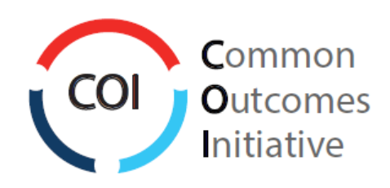

Common Outcomes Report (COR)
Work Book

Reporting Year
2020

Full User Guide is available on the Edmonton FCSS Website
OR
Full User Guide is available on the UWAY Website

Page 1 Common Outcomes Report
Please remember, you must complete one Common Outcomes Report for EACH PROGRAM/PARTNERSHIP you are funded through Edmonton Family and Community Support Services (Edmonton FCSS) and/or United Way of the Alberta Capital Region, (United Way).
You or someone in your organization, should have received ONE report link for each program.
You will report on your mandatory outcomes for this program/partnership as well as up to three additional outcomes of your choosing. If you are funded by Edmonton FCSS and/or United Way, there are mandatory outcomes or indicators that will populate automatically in this report. Please review the COR User Guide for a breakdown of these requirements.
The COR User Guide [link] is available to walk you through using, saving and submitting this report. This is a workbook of the questions in the report so you can prepare outside of the online document. Following completion of this report, the report will be emailed to yourself (the report writer), the program contact, and your funding contact. As a reminder, once you have submitted this report you are unable to make any changes.
Should you have any questions about completing the Common Outcomes Report, please reach out to your funding contact.
As a reminder, the reports are due January 31, 2021.
Page 2 Disclaimer
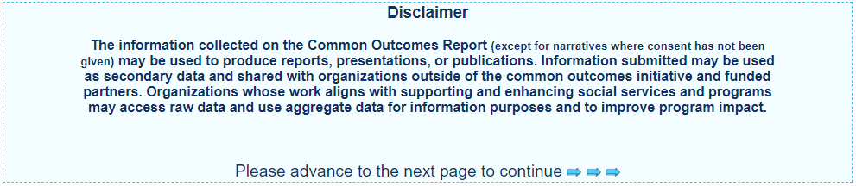
Page 3 Outline of the Report
This page in the online form outlines the different sections of the report that will be relevant for you.
Section 1: Overview
a) Agency and Program Information (Autofilled)
b) COR Report Recipient Contact Info (Autofilled/confirm/adjust)
c) Program Contact Info (Autofilled/confirm/adjust)
d) Program Description (Autofilled/confirm/adjust)
e) 211 Update
Section 2: Funding & Program Supports
a) Funding (Autofilled/identify other sources of revenue)
b) Program Supports (FTE/Students/Volunteers)
Edmonton FCSS Funded Programs: Additional Program Specific Questions
a) FCSS Partnership Information for Partnership/Collaboration funding only (Partnership Summary)
b) FCSS Information and Referral for Information and Referral Programs Only (Referrals/Interactions/Social Media)
United Way Funded Programs: Additional Program Specific Questions
a) Fundraising questions
b) Additional program information
Section 3: Unique Participants
a) Unique Participants
b) Indigenous Participants
c) Newcomer Participants
d) Participants by Geographic Community (UWAY only)
e) Participants by Gender Identity (UWAY only)
Section 4: Mandatory & Optional Indicators [this section will look different depending on who you are funded by]
a) Report on two (2) mandatory Edmonton FCSS outcomes/indicators (Edm FCSS Mandatory Outcomes will auto-populate)
b) Report on one (1) United Way indicator for the assigned Desired Result (United Way Desired Results will auto-populate)
c) Choose to report two (2) additional United Way indicators for the assigned Desired Result and/or
d) Choose to report on additional outcomes & indicators from the COR list
Section 5: Summary
a) Success Stories
b) Reflection Questions
Section 1a: Agency Overview
This information will be auto-populated based on the data provided in last year’s COR report. If you believe any of it is incorrect, please contact your funding contact.
Agency Name: This will now be auto-populated.
Program/Partnership Name: This will now be auto-populated.
Edmonton FCSS Liaison (if applicable): This will now be auto-populated.
United Way Manager(if applicable): This will now be auto-populated.
Section 1b: Common Outcomes Report Recipient
This is the person who fills out the common outcomes report. It will be auto-populated based on the data provided in last year’s COR report.
COR Outcomes Report recipient name: This will now be auto-populated.
COR Outcomes Report recipient email: This will now be auto-populated.
Is the contact information above accurate? Yes or No
If no, please correct:
COR Outcomes Report recipient name: ___________________________
COR Outcomes Report recipient email: ___________________________
Section 1c: Program Contact Information
This is the person who is the main contact for the program. It will be auto-populated based on the data provided in last year’s COR report.
Program/Partnership Contact Name: This will now be auto-populated.
Program/Partnership Email: This will now be auto-populated.
Program/Partnership Phone: This will now be auto-populated.
Is the contact information above accurate? Yes or No
If no, please correct:
Program/Partnership Contact Name: ___________________________
Program/Partnership Email: ___________________________
Program/Partnership Phone: ___________________________
Section 1d: Program Details
Program/Partnership Description: The description from last year’s COR report will be auto-populated. If the information is incorrect or requires an update, you can indicate as such and update the program name or description.
Is the program/partnership information above accurate? Yes or No
If no, please correct:
Adjusted Program/Partnership Name: ___________________________
Adjusted Program/Partnership Description Please note, this description is limited to 2-3 sentences (500 characters) and is used publicly. _____________________________________________________________________________________________________________________________________________________________________________________________________________________________________________________________________
Section 1e: 211 Update

Is your agency’s listing in the 211 database accurate and up-to-date?
Visit your COR Invitation email for a link to your agency's listing
- Yes
- No
- Our agency is not listed in the 211 database

If not, have you contacted 211 to update or create this information? To update or create your listing, please contact the 211 Community Resource Department at database@ab.211.ca or 780-392-8722
- Yes
- No

Section 2a: Funding for [Program Name]
Edmonton FCSS Core Funding: This will now be auto-populated, if you are funded by Edm. FCSS
Edmonton FCSS Other: This will now be auto-populated, if you are funded by Edm. FCSS other funding.
United Way of the ACR Funding: This will now be auto-populated if you are funded by UWAY
*If you feel your funding amounts are incorrect, please reach out to your funding contact.

Are the COR funders (UWAY or Edm FCSS) the program’s sole funder(s)? Yes or No
(Sole funders indicates that this program is entirely funded by one or more of the COR funders)
If not, what other sources of funding are used for THIS program/partnership?
- AGLC/Casinos Amount: ____________
- Canada Summer Jobs Amount: ____________
- Donations Amount: ____________
- Edmonton Community Foundation Amount: ____________
- Fundraising Amount: ____________
- In-Kind Amount: ____________
- Revenue from membership and/or fees Amount: ____________
    - Sponsorship (Corporate) Amount: ____________
- Other City of Edmonton Funding Amount: ____________
- Other Government of Alberta Funding Amount: ____________
- Other Government of Canada Funding Amount: ____________
- Other Foundation Funding Amount: ____________
- Other Nonprofit Organizations Amount: ____________
- Other Municipal Government Funding Amount: ____________
- Other Provincial FCSS funding Amount: ____________
- Other _______________________ Amount: ____________
This “other funding” data, helps us to provide a picture of where funds are coming from outside of the two funders and how they contribute to the programs/partnerships that report to the COR.
Please note, if you select a box, enter an amount and then unselect the box, the total funding still calculates it. Ensure any data removed (boxes unchecked), that any data entered is also deleted from the amount boxes.
Section 2b: Program Supports

FTE’s (Full time equivalent)
Total Number Service Delivery FTEs for this Program (funded by all sources):
Enter # of FTEs for THIS PROGRAM ____________
[Partnerships only]
Total Number of Service Delivery FTEs for this Partnership (funded by all sources):
Enter # of FTEs for THIS PROGRAM/Partnership ____________
(For example, staff that are paid for through the partnership funding or accounted for in the budget)
Enter # of FTES that are in-kind for this partnership ___________
(For example, staff that are attending the partnership table as part of their paid position elsewhere, i.e. none of the funding supports paying these partner participants)

Students & Volunteers
Does your program/partnership use:
- Students/Practicum Students
- Volunteers
- Both
- Not applicable (program does not use volunteers)
If your program/partnership uses students:
Number of student/practicum volunteers:
Enter # of student/practicum hours for THIS PROGRAM/partnership ___________________
Number of student/practicum hours:
Enter # of student/practicum hours for THIS PROGRAM/partnership _______________________
If your program/partnership uses volunteers:
Number of volunteers:
Enter # of volunteers for THIS PROGRAM/partnership ___________________
Number of volunteer hours:
Enter # of volunteer hours for THIS PROGRAM/partnership ___________________

Section 2c: FCSS Specific Questions (Only for those funded by Edmonton FCSS)

Partnerships & Initiatives
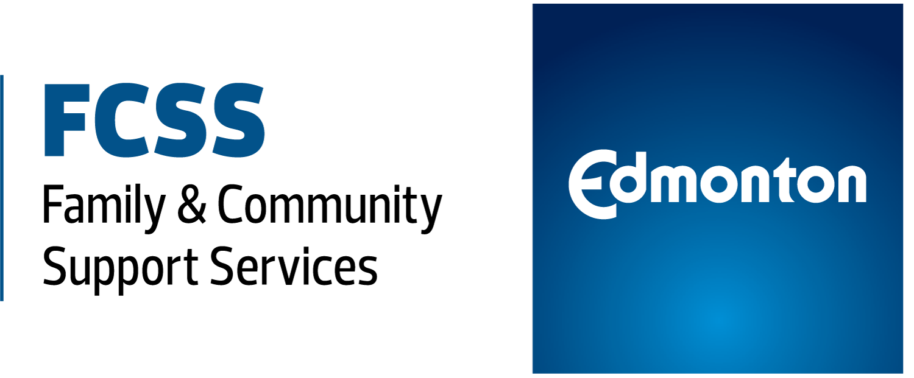
Only partnerships/collaborations that are funded specifically for working together will complete this page. All other funded programs no longer need to report on partnerships in the Common Outcomes Report.
Name of the Partnership: [auto populated]
Primary Focus of the Partnership (select one):
Categories for the Primary Focus: Anti-bullying, Community Mental Health Issues, Common Service Access, Community Capacity Building, Family Violence Prevention, Early Childhood Development, Homelessness, Inclusion and/or Diversity, Neighbourhood Building, Poverty Reduction, Safe Communities, Social Connection, Senior Wellness, Substance Abuse Prevention, Youth Engagement, Other
Number of partners involved: _____________
List of Partners:
_____________________________________________________________________________________________________________________________________________________________________________________________________________________________________________________________________
What were the main accomplishments of the partnership/collaboration this year?
_____________________________________________________________________________________________________________________________________________________________________________________________________________________________________________________________________

Please describe how this partnership (from your program’s perspective) is contributing to the identified focus.
_____________________________________________________________________________________________________________________________________________________________________________________________________________________________________________________________________

Information & Referral
FCSS Information & Referral Only: These questions ONLY show up if you are funded by EDMONTON FCSS and report in the Information & Referral Program Area.
If you do not collect this data, you do not have to report it. If you do collect some or all of this data, please report as much as you can and select not applicable if you do not collect data in a specific category.
Do you collect information and referral information?
- Yes
- No
If yes, please complete as much of the following information as possible:
Please select the types of information/referral requests you receive via:
- Phone Calls ___________
- Emails ___________
- Walk-ins ___________
- Not applicable ___________
To the best of your ability, please provide any of the information sharing that occurred through the number of:
- Newsletters sent out ___________
- Website hits ___________
- Participants at Information Fair(s)/Evening(s)/Session(s) ___________
- Not applicable ___________
To the best of your ability, please provide any social media interactions you had using:
- Facebook Followers: ___________
- Twitter Followers: ___________
- Other Social Media: ___________
- Not applicable ___________
Section 2c: UWAY Specific Questions (Only for those funded by UNITED WAY)
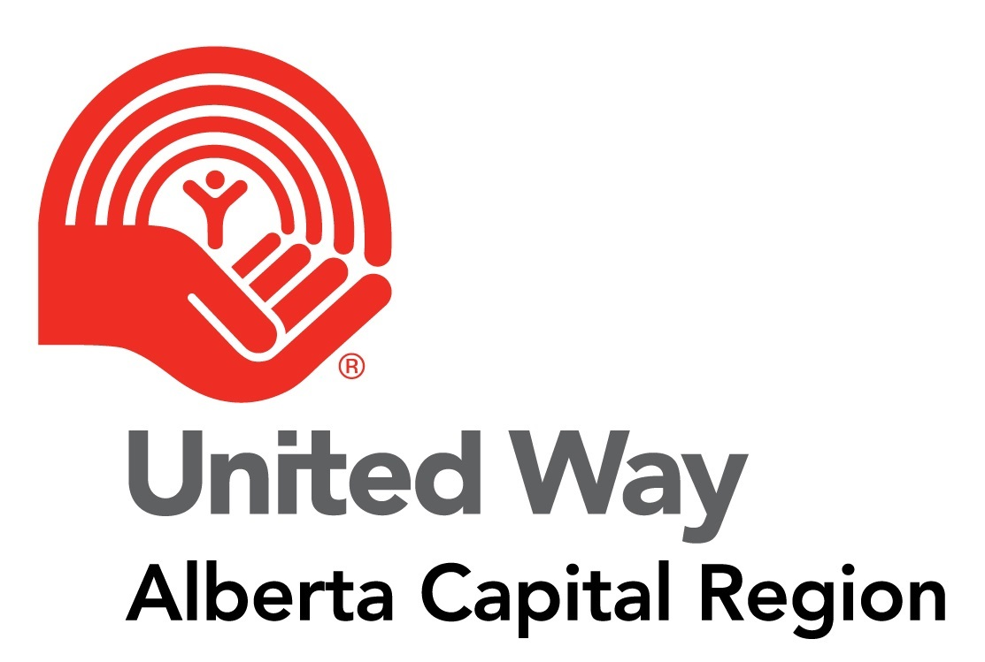

Please provide one or two sentences that demonstrate outputs and the impact your organization has on the community OR if your program offers services to clients, please link your program outputs to the impact on clients served. i.e. In 2020, 15,051 backpacks filled with school supplies were given to K-12 students (500 characters)
_____________________________________________________________________________________________________________________________________________________________________________________________________________________________________________________________________________________________
Occasionally, our business and community partners host product drives for our funded partners. If applicable, what are the top three needed items for this program?
1.
2.
3.

If applicable, list three small to medium sized projects that United Way Day of Caring volunteers could complete to support your program (i.e. event support, sorting items, painting, renovations, etc).
1.
2.
3.
Have there been any changes to program activities, scope or demographics from what was listed on Schedule B of your program funding agreement? Yes or No
If yes, describe changes: ____________________________________________________________________________________________________________________________________________________________________________________________________________________________________________________________________________________________
Provide an example of how the program contributed to Pathways out of Poverty. (500 characters)
_____________________________________________________________________________________________________________________________________________________________________________________________________________________________________________________________________________________________
Is there an/or will there be a program surplus or deficit for the most recent fiscal year?
- Yes, there is a program surplus
- Yes, there is a program deficit
- No, there is no program surplus or deficit
If you are reporting a surplus or deficit for the most recent fiscal year, please complete the following questions:
_______________ dollar amount of surplus or deficit dollars
What are the agency/program plans to address the surplus or deficit?
___________________________________________________________________________________________________________________________________________________________________________________________________________________________________________________________________________

Section 3a: Unique Participants by Age Category
Which age categories do these participants fall under:
- 0-5 # of participants 0-5: ___________________
- 6-12 # of participants 6-12: ___________________
- 13-17 # of participants 13-17: ___________________
- 18-24 # of participants 18-24: ___________________
- 25-64 # of participants 25-64: ___________________
- 65+ # of participants 65+: ___________________
- Age Unknown # of participants age unknown: ___________________
Total Unique Participants for this program/partnership _______________(this will auto-calculate in the form)
Please elaborate on the difference in unique participant numbers from last year to this year. Your response to this question is for information purposes only. It will help us to understand and provide context to the unique participant numbers reported each year. ________________________________________________________________________________________________ ________________________________________________________________________________________________
Page 3b: Participant Demographics for Self-Identified Indigenous
Do you collect data on the number of Indigenous participants your program serves? Yes or No
If yes, please provide the breakdown of self-identified Indigenous participants by age. NOTE: only the age groups selected in section 3a will be visible on the online form.
Which age categories do these participants fall under:
- 0-5 # of participants 0-5: ___________________
- 6-12 # of participants 6-12: ___________________
- 13-17 # of participants 13-17: ___________________
- 18-24 # of participants 18-24: ___________________
- 25-64 # of participants 25-64: ___________________
- 65+ # of participants 65+: ___________________
- Age Unknown # of participants age unknown: ___________________
Page 3c: Unique Participants Self-Identified as a Newcomer
Do you collect data on the number of self-identified Newcomer participants served by your program? Yes or No
If yes, please provide the breakdown of self-identified Newcomer participants by age. NOTE: only the age groups selected in section 3a will be visible on the online form.
Which age categories do these participants fall under:
- 0-5 # of participants 0-5: ___________________
- 6-12 # of participants 6-12: ___________________
- 13-17 # of participants 13-17: ___________________
- 18-24 # of participants 18-24: ___________________
- 25-64 # of participants 25-64: ___________________
- 65+ # of participants 65+: ___________________
- Age Unknown # of participants age unknown: ___________________
NOTE: The total number of Indigenous and/or Newcomer participants, cannot exceed the total unique participants reported in section 3a.
Page 3d: UWAY Only: Participant Data by Community for Programs funded by United Way
Please select communities where you served participants last year:
- City of Edmonton # of participants: ___________________
- City of Fort Saskatchewan # of participants: ___________________
- City of Leduc & Leduc County # of participants: ___________________
- St. Albert & Sturgeon County # of participants: ___________________
- Stony Plain, Spruce Grove & Parkland County # of participants: ___________________
- Strathcona County # of participants: ___________________
- Out of Province # of participants: ___________________
- Unknown Communities # of participants: ___________________
- Other # of participants: ___________________
NOTE: The total number of participants by Geographic Location, cannot exceed the total unique participants reported in section 3a. If you have location for some but not all of your participants, please enter the remaining participants in the category “Unknown.”
For example, if you have 300 total unique participants, but only location data for 200 of them. Then you put 100 in the category of “Unknown” and assigned the other 200 accordingly.
Page 3e: UWAY Only: Participant Data by Gender for Programs funded by United Way
Does your agency/program collect gender identity information for program participants?
- Yes
- No
If yes, please provide the following:
How many of 18+ participants identified as:
- Boy/Man/Male # of participants: ___________________
- Girl/Woman/Female # of participants: ___________________
- Gender Diverse # of participants: ___________________
- Gender Identity Unknown # of participants: ___________________
NOTE: The total number of participants by gender identity, cannot exceed the total unique participants reported in section 3a. If you have the gender identity data for some but not all of your participants, please enter the remaining participants in the category “Gender Identity Unknown.”
For example, if you have 300 total unique participants, but only gender identity data for 200 of them. Then you put 100 in the category of “Gender Identity Unknown” and assigned the other 200 accordingly.

Section 4: Outcome Reporting
Mandatory Outcomes will be auto-populated
Edm FCSS Funding only?
Outcome 1 and 2 will be your mandatory outcomes/indicators as per your funding letter/agreement (can report up to 3 additional)
Edm FCSS & UWAY Funding?
Outcome 1, 2 and 3 will be your mandatory outcomes/indicators as per your funding letters/agreements (can report up to 2 additional)
UWAY Funding only?
You must report on the mandatory outcome as per your funding agreement (can report up to 4 additional)
Capacity Building with only UWAY funding?
No mandatory outcomes, select which outcomes you would like to report (report at least 2 and up to 3 additional outcomes)
FCSS Mandatory Outcomes (if applicable)
Mandatory Outcome #1: ________________________________________________
Indicator #1: ________________________________________________
Mandatory Outcome #2: ________________________________________________
Indicator #2: ________________________________________________
United Way Desired Result Outcome/Indicator (if applicable)
Mandatory Indicator #1 (if applicable): ________________________________________________

Capacity Building Funded (UWAY only)
Outcome #1: ________________________________________________
Indicator #1: ________________________________________________
Outcome #2: ________________________________________________
Indicator #2: ________________________________________________

Additional Outcomes (optional, you can report one, two or three additional outcomes of your choosing):
Outcome #1: ________________________________________________
Indicator #1: ________________________________________________
Outcome #2: ________________________________________________
Indicator #2: ________________________________________________
Outcome #3: ________________________________________________
Indicator #3: ________________________________________________

The following page represents the data you need for each of the outcomes you report.
Section 4 (continued): Indicator(s), Tool(s), & Data
Outcome
Select Outcome #1. This will auto populate if you have a mandatory outcome, if you do not have a mandatory outcome choose the indicator you would like to report on.
Outcome: ________________________________________________
Indicator
Select Indicator #1 This will auto populate if you have a mandatory outcome, if you do not have a mandatory outcome choose the indicator you would like to report on.
Indicator: ________________________________________________
Outcome & Indicator - Tools & Methodology
Please select when you collected the majority of the data: Choose One
- Pre
- Post
- Pre & Post
- During the Program
- During & Post
- Follow Up
- Pre, During & Post
Please select the tool most frequently used to collect the data: Choose One
- Administrative Statistics
- Direct Observation
- Group Discussion
- Interviews
- Review of charts or other documentation of participant progress
- Surveys/questionnaires
- Text Messages

If you used a survey tool, what question(s) did you use to gather data on this indicator? Open Ended
________________________________________________________________________________________

Number of Participants Tried to Collect Data From: __________________
Number of Participants Responded: __________________
Number of Participants That Experienced a Positive Change: __________________

Describe what positive change looks like for this outcome as seen through participants' own words, actions, or changes in their lives that further explain the numbers you have just reported? Open Ended
______________________________________________________________________________________________________________________________________________________________________________________________________________________________________________________________________
**Repeat this page based on the number of outcomes you will be reporting (up to 5, including mandatory outcomes)**
Section 5a: Success Story
Success Story
This is an opportunity for your program to share a success story regarding the impact your program or partnership has had on participants. The stories are read by the funders and used in the Common Outcomes Report roll up as well as other reporting documents to illustrate impact in a qualitative story form.
Please remember to remove the names of any staff or participants.
Enter your success story here: Essay maximum 3000 characters
______________________________________________________________________________________________________________________________________________________________________________
______________________________________________________________________________________________________________________________________________________________________________
______________________________________________________________________________________________________________________________________________________________________________
______________________________________________________________________________________________________________________________________________________________________________
______________________________________________________________________________________________________________________________________________________________________________
______________________________________________________________________________________________________________________________________________________________________________
_______________________________________________________________________________________________________________________________________________________________________________
Section 5b: Success Story Consent
Permission to share your program’s success story:
By checking yes you are allowing the success story to be used by the two funding bodies for the Common Outcomes Report and other dissemination. We assume that this means that you have also received permission from the participant.
- Yes, we provide consent to share the success story.
- No, we choose to keep the success story private.

Section 5c: Reflection Questions (Program Funding)
Thinking about the program...
Tell us about some evaluation learnings you had in the last year. Discuss with your team and provide one or two examples. Open ended
____________________________________________________________________________________________________________________________________________________________________________________________________________________________________________________________________________________________________________________________________________________________
Thinking about the trends in the community…
What are the most prominent and important trends or issues affecting participants that are accessing the program? Open ended
______________________________________________________________________________________________________________________________________________________________________________
______________________________________________________________________________________________________________________________________________________________________________
Thinking about deeper, enduring impact for participants...
How are participant's lives being changed as a result of the program? Open ended
______________________________________________________________________________________________________________________________________________________________________________
______________________________________________________________________________________________________________________________________________________________________________
Thinking about the barriers to success...
Please select barriers outside of core programming that you have had to address through additional program planning, activities and/or budget.
- Access to computers/technology
- Access to cultural teachings, language, learning
- Childcare
- Clothing
- Connection to community resources
- Counseling
- Employment supports (i.e. work wear, resumes etc)
- Food
- Housing Supports
- Literacy
- Transportation
- Mental Health & Addictions
- None of the Above

Please select barriers outside of core programming that you ARE NOT able to address.
- Access to computers/technology
- Access to cultural teachings, language, learning
- Childcare
- Clothing
- Connection to community resources
- Counseling
- Employment supports (i.e. work wear, resumes etc)
- Food
- Housing Supports
- Literacy
- Transportation
- Mental Health & Addictions
- None of the Above

Are there any other or new barriers program participants are facing?
- Yes
- No

Describe Barriers Open ended optional
_____________________________________________________________________________________________________________________________________________________________________________________________________________________________________________________________________

If so, how have you been trying to address them? Open ended optional
________________________________________________________________________________________
________________________________________________________________________________________

Section 5c: Reflection Questions (For Partnership Funding ONLY)
Thinking about the partnership/collaboration:
Tell us about some evaluation learnings you had in the last year. Discuss with your team and provide one or two examples.
______________________________________________________________________________________________________________________________________________________________________________
______________________________________________________________________________________________________________________________________________________________________________
Thinking about the impact on the community:
Please describe how the community impact was increased or decreased due to the work of the partnership/collaboration. If there were challenges, how did you overcome them?
______________________________________________________________________________________________________________________________________________________________________________
______________________________________________________________________________________________________________________________________________________________________________

Thinking about working together:
By working together, has the partnership/collaborations identified new ways to solve problems? Please explain.
______________________________________________________________________________________________________________________________________________________________________________
______________________________________________________________________________________________________________________________________________________________________________
How has working in partnership/collaboration increased your ability to more effectively meet the needs of our participants or the community (for example, freed up resources, gained access to new resources, gained expertise, increased efficiency, etc.)? If it hasn’t, why do you think that is?
______________________________________________________________________________________________________________________________________________________________________________
______________________________________________________________________________________________________________________________________________________________________________
Thinking about deeper, enduring impact for participants or systems...
How is the work of the stakeholders/partners changing the lives of participants or the system they are within?
______________________________________________________________________________________________________________________________________________________________________________
______________________________________________________________________________________________________________________________________________________________________________

COVID-19 Questions (Optional)

How did your program adapt delivery in response to COVID-19?
_____________________________________________________________________________________________________________________________________________________________________
______________________________________________________________________________________________________________________________________________________________________________
Did this impact the information provided in this report?
- Yes
- No

How have participants in this program been impacted by COVID-19?
_____________________________________________________________________________________________________________________________________________________________________________
______________________________________________________________________________________________________________________________________________________________________________
How have program adaptations affected your program delivery going forward?
_____________________________________________________________________________________________________________________________________________________________________________
______________________________________________________________________________________________________________________________________________________________________________
Learning from the last few months, what could we, as a community, do differently to effectively respond to any large scale emergencies?
_____________________________________________________________________________________________________________________________________________________________________________
______________________________________________________________________________________________________________________________________________________________________________
Section 5e: Supplementary Information (Optional)
Use the space below to provide additional information, context or clarifying notes.
______________________________________________________________________________________________________________________________________________________________________________
______________________________________________________________________________________________________________________________________________________________________________
If you have an additional research or evaluation report/publication you would like to ensure the funders receive, please link to it here. Please note, this is optional and only provided for agencies to showcase additional research, outcomes and evaluation work.
____________________________________________________________ (provide link)

COR Summary
Proof of COR Report submission will be emailed to the following people:
1. COR Report Recipient
2. Program Contact
3. Funder(s)

Please remember, all reports must be complete via
the ONLINE FORM.
The Common Outcomes Reports are due on JANUARY 31st, 2021.

