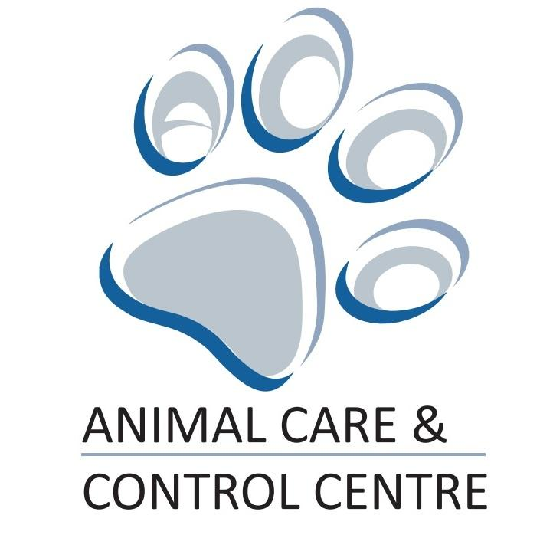 | Animal Rescue Fund  Application  2018

Submit application to:
Community Relations Advisor
Animal Care & Control Centre
13550 163 Street NW
Edmonton, AB T5V 0B2

Telephone: 780-495-0327

Email: tanya.laughren@edmonton.ca

Animal Rescue Fund Application

The Animal Rescue Fund (ARF) is a grant program that provides funding to not-for-profit pet rescue organizations in order to benefit animals rescued within the Edmonton area. Up to one grant submission is allowed per rescue organization per quarter for each calendar year, subject to the availability of funds. Applications will be assessed on a first come-first served basis each quarter. To ensure a wide distribution of funds, rescue organizations that received an ARF grant in a previous quarter will only be considered for another ARF grant after the other applications for the current quarter have been assessed and if funds are still available.

Important Deadlines
 | DEADLINE TO APPLY | FINAL REPORT DUE
First Quarter  January 1 - March 31 | March 15 | December 15
Second Quarter  April 1 - June 30 | June 15
Third Quarter  July 1 - September 30 | September 15
Fourth Quarter  October 1 - December 15 | November 30

Application Checklist
ARF Grant Application Requirements
- Good Standing: The rescue organization does not owe any outstanding fines or fees to the Animal Care & Control Centre (ACCC). The rescue organization has provided all required final reports from previous ARF grants and repaid the City of Edmonton any funding from previous ARF grants that were not spent (if applicable). The rescue organization is also not under any current investigations by ACCC, EHS or Alberta SPCA.
- Completed ARF grant application form (Part A, B and C).
- Proof of Federal Registered Charity Status: Proof of registration (including charitable registration number) as a charitable organization whose primary objectives are pet rescue/pet adoption.
- Proof Certificate of Insurance: Proof of an insurance policy that covers property damage and bodily injury in an amount not less than $2 million inclusive limit for any one occurrence.
- Proof of Spay/Neuter Policy: Proof that the rescue organization’s has a policy to spay/neuter pets before they are adopted.
- Proof of Pet I.D. and Licensing Policy: Proof that the rescue organization encourages pet owners to license their new cat or dog with their local municipality and permanently I.D. the animals using a microchip or tattoo.
- Information on Animals in Care: Information about how the animals that will benefit from the ARF grant came into the rescue organization’s care (e.g., surrender contracts, EHS documentation, ACCC ID number, etc.)
- Photos: Pictures of the animals in care that will benefit from the ARF grant funding.
- Project Budget: An estimated budget has been included for the project or initiative that is the subject of this ARF grant funding application.

Please submit the completed application and all required supporting
documents via email or mail to the Community Relations Advisor.

Animal Rescue Fund (ARF) Guidelines

Who can apply?

Rescue organizations that meet the following criteria are welcome to apply for ARF grants:
- Acts Locally: Rescue organization is located in Edmonton, Alberta, and/or primarily provides animal rescue / animal adoption services within the City of Edmonton.
  - Note: If a rescue organization’s target community is not Edmonton-based, the organization is still welcome to apply for ARF grant funds to support animals that had previously been surrendered by Edmonton residents, in the care of the Edmonton Humane Society or the Animal Care and Control Centre.
- Non-Profit Organizations: Registered as federal charity whose primary purpose involves pet rescue, pet adoption and/or humane animal care. The ARF grants are not available to individuals or for-profit businesses.
- Insured: Carry liability insurance of not less than $2 million for any one occurrence
- Spay/Neuter Policies: Have a policy of spaying/neutering their rescue animals prior to these animals being adopted
- Licensing/Pet ID Policies: Have a policy of promoting pet licensing / pet identification for all rescued animals
- Promote Compliance: In good standing with Animal Care and Control Centre and Edmonton Humane Society (e.g., no delinquent pet accounts, no outstanding fines/fees, no overdue funds / reports from previous ARF grants, no ongoing investigations by Edmonton Humane Society, Animal Care and Control Centre and/or Alberta Society for the Prevention of Cruelty to Animals)
  - Special consideration will be given to rescue organizations that are members of the Edmonton Animal Rescue Alliance.

What types of initiatives qualify for an ARF grant?

ARF grant funding can be used towards the following types of programs/initiatives:
- Medical/Dental Care: Providing medical care or dental care for rescued animals, including vaccinations or spay/neutering.
- Pet Identification: Microchipping or tattooing rescued animals for identification purposes.
- Behavior Training: Providing behavior training classes for qualifying animals.

Animal(s) that benefit from ARF grant funding should meet at least one of the following criteria:
- The animal was surrendered from a City of Edmonton resident;
- The animal was transferred from the Animal Care & Control Centre to the rescue organization; and/or
- The animal was previously in the care of the Animal Care & Control Centre or the Edmonton Humane Society, and then was transferred to the rescue organization.
PLEASE NOTE: A rescue organization can apply for an ARF grant that will benefit multiple animals. However, only animals that came into the care of the rescue organization during the previous year or current year will qualify for the ARF grant funds. The rescue organization must provide a documented history for these animals that proves when and how the animals came into care.

What are the application and funding limits?

Each calendar year, up to one grant submission is allowed per rescue organization per quarter, subject to the availability of funds. In other words, a rescue organization is allowed to apply for ARF grant funding a maximum of four times per year.

Applications will be assessed on a first come-first served basis each quarter. To ensure a wide distribution of funds, rescue organizations that received an ARF grant in a previous quarter will only be considered for another ARF grant after the other applications for the current quarter have been assessed and if funds are still available.

For each grant application, a rescue organization may apply for up to $2,000.00 of funding.

 | DEADLINE TO APPLY
First Quarter  January 1 - March 31 | March 15
Second Quarter  April 1 - June 30 | June 15
Third Quarter  July 1 - September 30 | September 15
Fourth Quarter  October 1 - December 15 | November 30

Under Part B and C of the application form, a rescue organization must outline:

- The proposed use of the ARF grant funding
- A budget for the project that is the subject of the ARF grant funds. This includes:
  - Anticipated expenses - these are the costs that the rescue organization is requesting funding for through the ARF grant
  - Anticipated resources - these are the donations / in-kind contributions / volunteer services and mileage that the rescue organization anticipates it will be able to dedicate to the project. These resources are not provided through the ARF grant but through the rescue organization’s partners, donors, volunteers, etc.

All applications must include evidence of donations / in-kind contributions / volunteer services, etc., that will come from other external sources.

Application approval process

In reviewing an ARF grant application, the City of Edmonton will consider the proposed use of the ARF grant funding, the proposed budget, and the anticipated benefits to the Edmonton community. Once an ARF grant application has been approved, the City of Edmonton will forward a copy of an Agreement setting out the confirmed grant funding amount. This Agreement must be signed on behalf of the rescue organization by a representative with legal signing authority

Final Report and Final Expenditure Summary

All rescue organizations that have been approved for an ARF grant are expected to submit a Final Report and Final Expenditure Summary on the use of the ARF grant funds by December 1st of each calendar year.

A rescue organization is expected to complete a Final Report and Final Expenditure Summary for every ARF grant received, even if that rescue organization has received more than one ARF grant in that calendar year. In other words, if a rescue organization has received three ARF grants, it must complete and submit three final reports.

The Final Report and Final Expenditure Summary include information on how the ARF grant money was spent, as well as a summary of the project’s actual expenses / resources.

Copies of all original receipts/invoices must be included with the Final Report and Final Expenditure Summary.

Rescue organizations are also expected to keep the original copies of all their receipts and records relating to the project/initiative that is the subject of the ARF grant for a minimum period of six (6) years after the project/initiative has completed.

Any ARF grant funding that has NOT been spent at the time that the final report is submitted MUST be paid back to the City of Edmonton.

Any failure or delays in submitting the Final Report and Final Expenditure Summary, copies of receipts / invoices, or to return unspent ARF grant funds may impact future applications by a rescue organization for ARF grant funding.

Date Received: |  | Applicant No.

ANIMAL RESCUE FUND GRANT APPLICATION
PART A: APPLICANT INFORMATION
Please complete all of the requested information below. If the application does not provide sufficient space for your information, please attached additional pages to this application.

ORGANIZATION INFORMATION
Legal Name of Organization:
Charity Registration No.:
- Please attach proof of registration as a non-profit organization.
- Please attach a Certificate of Insurance.
Website: |  | Organization Email:
Organization Mailing Address:
Contact Name: |  | Contact Phone Number:
Contact Email:

- Provide a brief description of the pet rescue organization (history, mission, etc.):

The personal information on this form is being collected under the authority of Section 33 (c) of the Freedom of Information and Protection of Privacy Act, and will be used to administer the City of Edmonton’s Animal Rescue Fund (ARF) Grant Program. It will be treated in accordance with the privacy protection provisions of Part 2 of the Freedom of Information and Protection of Privacy Act. If you have any questions about the collection, use or disclosure of this information, please contact the Animal Care and Control Centre at 780-495-0327.
- Explain how the rescue organization supports pet rescue and adoption in the City of Edmonton area:

- Please attach the rescue organization’s spay/neuter policy.
- Please attach the rescue organization’s pet identification and licensing policy.

PART B: GRANT FUNDING REQUEST

- Explain the purposes for which the rescue organization is requesting the ARF grant funding. Please provide a detailed description of the project/initiative, applicable timelines, persons/organizations involved in the project’s delivery, and anticipated outcomes:

- Provide information on the animal(s) that will benefit from the use of the ARF grant funding being requested. Please include information on how these animals came into the rescue organization’s care.
- Please include photographs of the animals in care that will benefit from ARF grant funding.
- Please include supporting documentation (e.g., surrender contracts, Edmonton Humane Society documentation, etc.) that proves how the animals came into the rescue organization’s care

PART C: ANTICIPATED EXPENSES AND CONTRIBUTIONS

ANTICIPATED EXPENSES
Please provide a description of the anticipated expenses that require ARF grant funding.
Proposed Item/Description | Proposed Cost
1.
2.
3.
4.
5.
6.
7.
8.
9.
10.
11.
12.
13.
14.
15.
16.
17.
18.
19.
20.
TOTAL GRANT FUNDING REQUEST

ANTICIPATED RESOURCES
DONATIONS
Please provide a description of the anticipated monetary donations, in-kind donations, volunteer hours and mileage that will be contributed by the Organization, its staff, partners, donors or volunteers for the project/initiative.
In-Kind or Monetary Donations
Please include all monetary donations as well as in-kind donations such as
pet food donations, discounts from veterinary clinics, behavioral training discounts, etc.
Description |  | Value
TOTAL
Volunteer Labour/Mileage
Volunteer hours can be calculated at a rate of $15.00/hour.
Volunteer mileage can be calculated at a rate of $0.50/hour.
Description |  | Value
TOTAL
FINAL TOTAL OF ANTICIPATED RESOURCES

