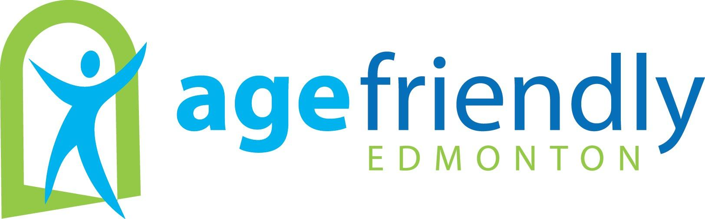

Project Proposal
Please complete and submit this Project Proposal Form when requesting funding from Age Friendly Edmonton

Contact Information
Name of Organization or Group: | Click here to enter text.
Mailing Address: | Click here to enter text.
Name of Contact Person: | Click here to enter text.
Title/Position: | Click here to enter text.
Phone number: | Click here to enter text.
E-Mail Address: | Click here to enter text.

Project Information
Name of Project: | Click here to enter text.
Start and End Dates for Project: | Click here to enter text.
Address where project will be delivered: | Click here to enter text.

Provide a complete project overview using the guiding questions below

Project Description
- Describe what the project is, why it is needed and who will benefit.
- Describe what will result from this project (tangible or intangible).
- Describe how seniors are involved in the planning or implementation of this project.
- Describe if and/or how this project will build on work already completed by this Working Group, Organization or by other stakeholders?

Click here to enter text.

Expected Outcomes
- Describe the short-term and long-term outcomes (what will change as a result of this project?).
- How will you know the project is successful? What specific key indicators will you use to measure success?
- Describe how this project will influence change in at least one of the following areas:
    - Increased awareness and knowledge
    - Policy change
    - Improved service delivery
    - Improved experiences for seniors and family

Click here to enter text.

Major Activities and Timelines
- Describe the major activities or phases of work that will occur.
- Identify who is responsible for completing the major activities or phases of work.
- Is there any flexibility in the project schedule?

Click here to enter text.

Budget
- Provide specific detail on the project’s budget breakdown.
- Is there any flexibility in the budget?
- Are there any other in-kind supports or financial resources being provided to this project?

Click here to enter text

Sustainability and Impact
- Utilizing the Sustainability and Impact Framework and Checklist (see below), describe the sustainability plan for this project.

Click here to enter text.

Connection with the Vision for an Age Friendly Edmonton
- Describe how this project supports the 2011 Vision for an Age Friendly Edmonton Action Plan, specifically which Goal and Action this project is addressing. You can find the Action Plan on www.edmonton.ca/agefriendly

Click here to enter text.

Is the Board aware and supportive of this proposal?
Click here to enter text.

Submit completed proposal to:
agefriendly@edmonton.ca

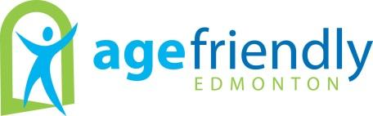
Sustainability and Impact Framework

What is the AFE definition of Sustainability?
- We have accomplished what we intended. We have changed something and no new resources or inputs are required.
- We have created something that an existing partner can incorporate on its own with existing resources.
- We recognize that in order to achieve the vision of Age Friendly Edmonton, we will create some projects/programs/areas of work that will need ongoing resources.

What is the AFE definition of Impact?
- We are focused on lasting and long-term change.
- We recognize that the effects of our efforts may be felt at various levels:
  - Increased awareness and knowledge
  - Policy change
  - Improved service delivery
  - Improved experiences for seniors and family

How do these terms influence the projects we undertake?
Project Planning
- We consider questions of sustainability and long-term impact when conceptualizing and planning projects (See Sustainability and Impact Checklist)

Project Funding
- In addition to asking questions of sustainability and long-term impact, Executive will consider the following:
  - Is there evidence of stability in terms of leadership and resources for the project?
  - Do the involved partners have the combined expertise and resources required?

Evaluation
- While not all AFE projects receive formal evaluation, evaluative thinking is used in planning projects. Working Groups are expected to identify expected outcomes, indicators, and primary area of impact in all project proposals.

Sustainability and Impact Checklist

- Does the project fit to AFE Strategic Area goals and actions?
- Is there convincing evidence of need?
- Has the target audience (community) been consulted?
- Is there a logical fit between the project outcomes anticipated and:
  - The project design or process?
  - The level of human and other resources projected?
  - The size of our funding request?
  - The timeframe projected?
- Has a plan been developed for communication, monitoring, and evaluation?
- What resources are projected for the future?
- Where will the resources come from?
- Is this a new, existing, or ongoing project?
- Who else is involved?
- What is the role of each participant – staff, volunteers or participating agencies? Who is doing what?
- What is each participant contributing? What will each receive?
- Is everyone involved who should be - seniors, other community partners, Board Members, etc.?

